**Data Structures Lab 10 Report**

Group Members: Vivek Kunapareddy, Yuan Cheng

**Discussion of objectives/concepts:**

The concept explored in this lab assignment were B-trees. This is important in the data structures course and also in the software workforce as it is a fundamental data structure which is used widely. By implementing the data structure by ourselves we have a stronger understanding of how it works.

**Screenshots from Task 2:**

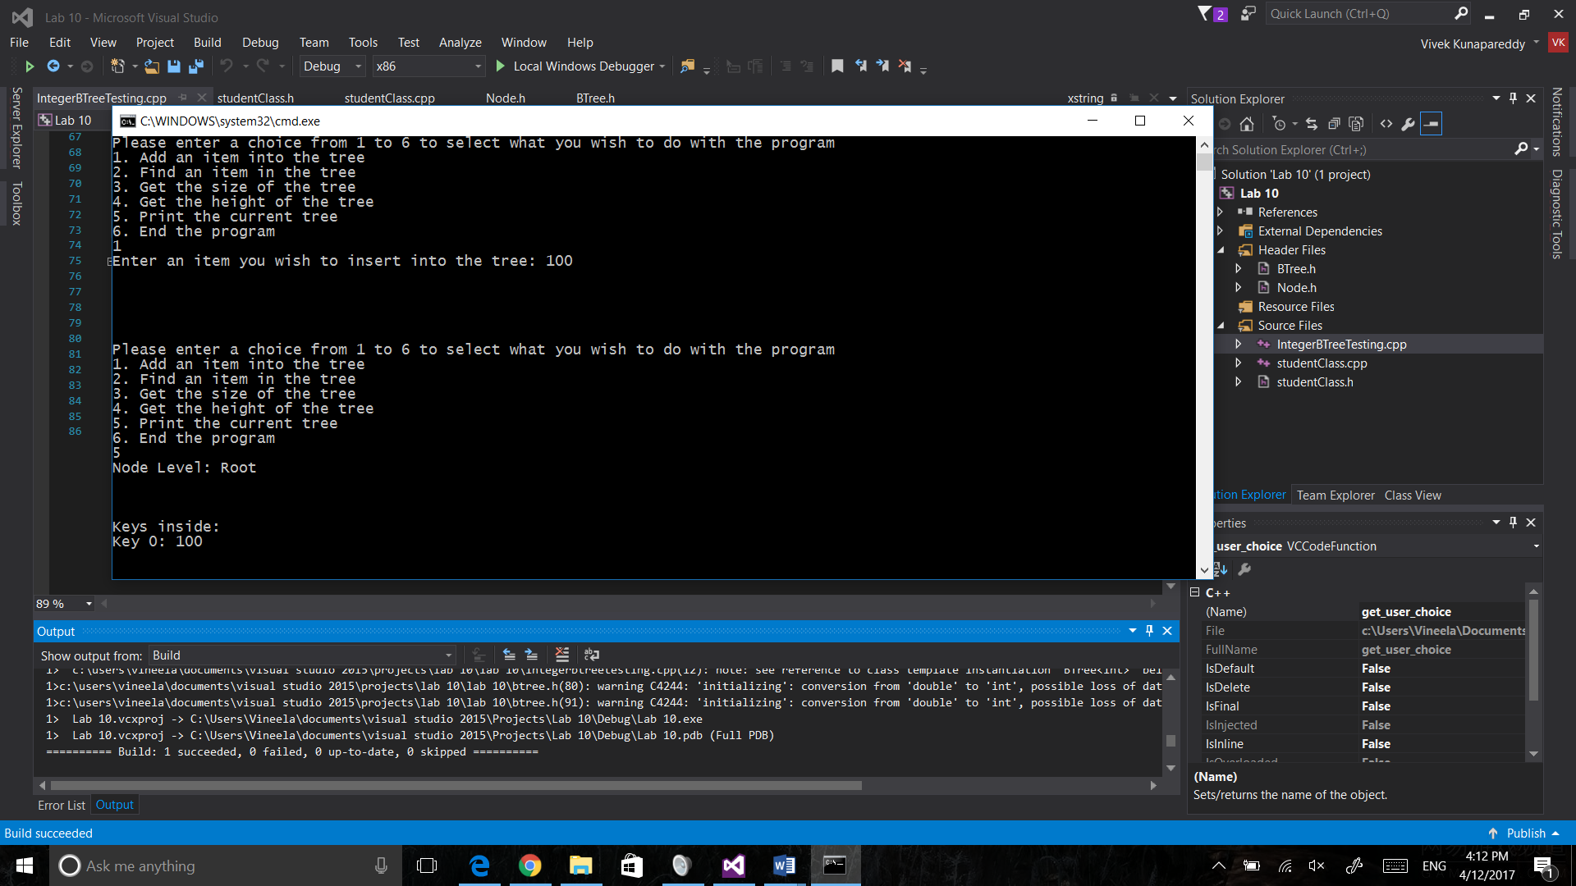

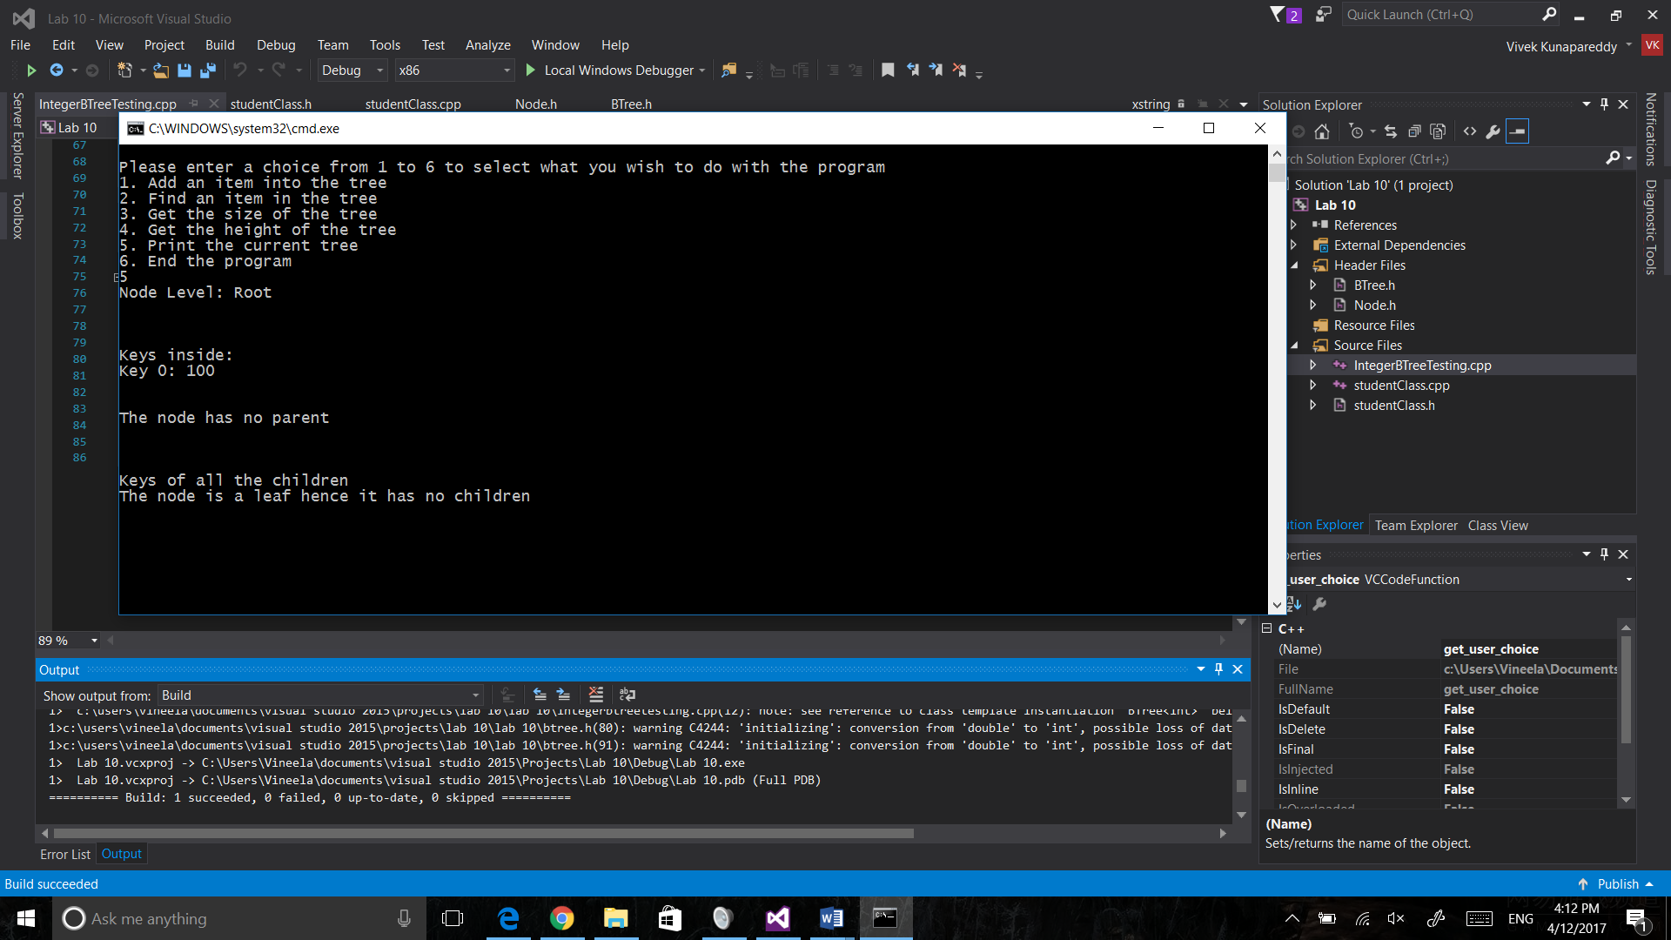

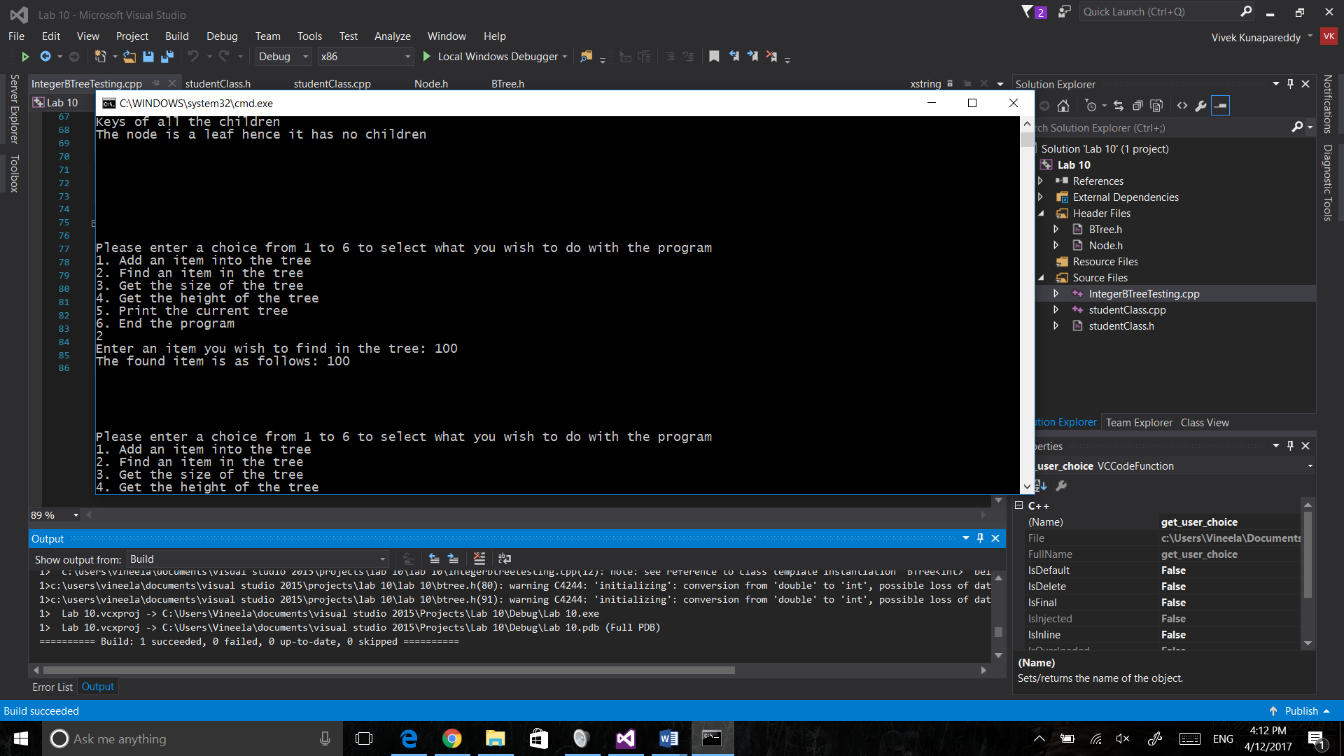

**Task 3 Discussion:**

|  |  |  |  |  |
| --- | --- | --- | --- | --- |
| Order of Tree | Trial 1 | Trial 2 | Trial 3 | Trial 4 |
| 3 | 237 | 289 | 304 | 287 |
| 4 | 216 | 222 | 220 | 217 |
| 5 | 156 | 159 | 155 | 156 |

Clearly from the above tree we can see that as the order of the tree increases, the number of operations to add and find an item decreases. This is obviously due to the fact that since the tree grows wider and has more branches to look into, it will no longer have to look as deep and follow as many pointer.

Another interesting trend to note is that as the order grows, the number of operations grows more stable. A good further experiment to conduct would be to check at what order the number of operations becomes the same for a large number of trials.

**Task 2 and 3 modifications:**

Task 2 required no modifications as it was just a simple testing of the tree.

Task 3 required changes where operations would be incremented whenever a pointer was followed within the tree

**Group contributions:**

Everything was done together

**Instructions to run/compile:**

When running the order testing file, make sure to change the global constant ORDER_CHOICE to change the order of the tree